**Bahria University, Lahore Campus**

Department of Computer Sciences

Lab Journal 13

**(Fall 2023)**

|  |  |  |
| --- | --- | --- |
| Course: | **Database Management System Lab** |  |
| Course Code: | CSL 220 | Max Marks: |
| Faculty’s Name: |  | Lab Engineer: |

Name: _AFFAN AHMAD___ Enroll No: _03-134221-003_____

**Task**

**Attach the document of your semester project. Please follow the component**

* **Introduction**
* **Background**
* **ERD of your project**
* **Methodology**
* **Conclusion**

**Note: document not more than 3 pages.**

**Title: Modernizing Healthcare: A Hospital Management System**

**Introduction:**In the dynamic landscape of healthcare, the efficient management of hospital operations is crucial for providing quality patient care. Our proposed project, the "Hospital Management System," aims to streamline and automate various administrative and clinical processes within a healthcare facility. This system leverages technology to enhance efficiency, improve patient outcomes, and optimize resource utilization.

**Background:**

**All 16 table :**

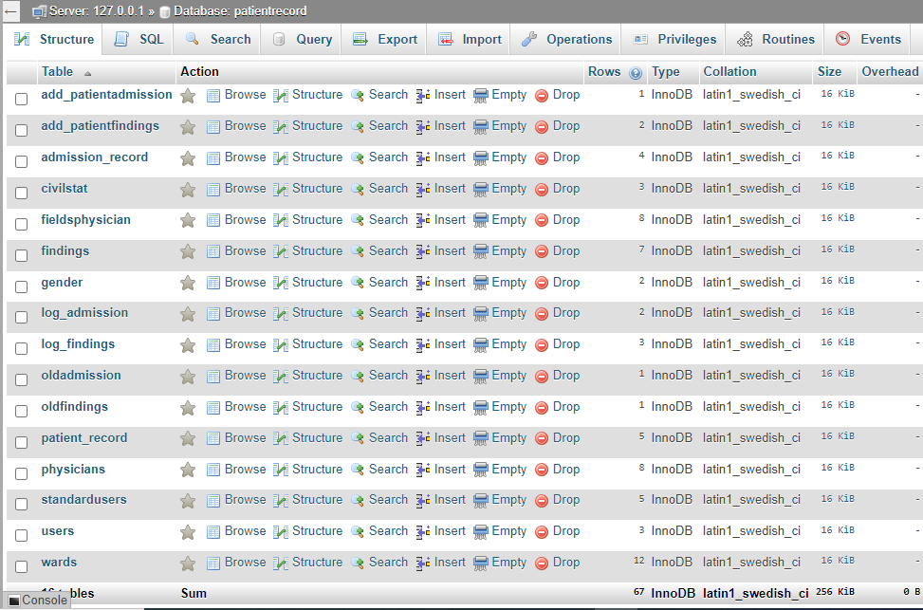

**ERD of project**

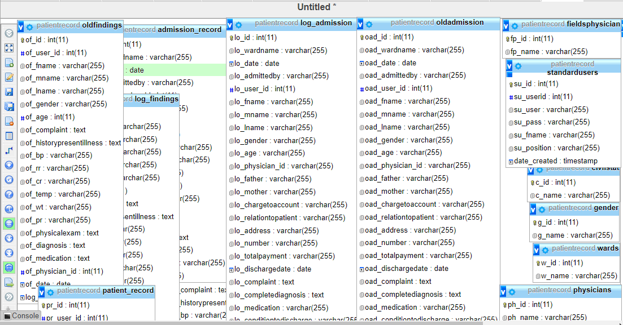

**Methodology diagram:**

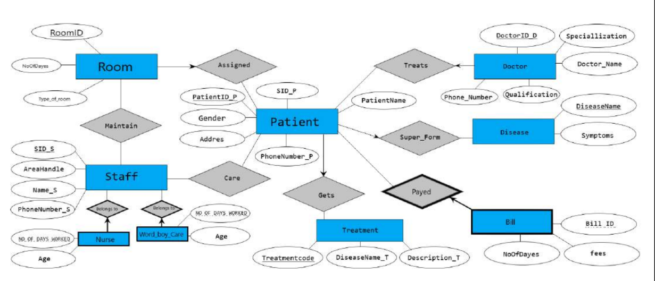

**Conclusion:**The Hospital Management System project addresses the critical need for modernizing healthcare administration and improving patient care. By implementing this system, we aim to contribute to the efficiency and effectiveness of healthcare facilities, ultimately enhancing the overall healthcare experience for both patients and healthcare professionals.

**Lab Grading Sheet :**

|  |  |  |  |
| --- | --- | --- | --- |
| **Task** | **Max Marks** | **Obtained Marks** | **Comments(*if any*)** |
| 1. | 10 |  |  |
| 2. | 10 |  |  |
| 3. | 10 |  |  |
| 4. | 10 |  |  |
| **Total** | **40** |  | **Signature** |

**Note : Attempt all tasks and get them checked by your Lab. Instructor**